# **INFO 6205 PSA SUMMER FINAL PROJECT**

**PRASAD PATHAK (002925486)**

**ANVITHA LAKSHMISHA (002965377)**

## TOPICS

1. Hibbard deletion of BST

According to the course lecture notes, after several (Hibbard) deletions have been made, the average height of the tree is √𝑛. Do you agree with this? How does it look after modifying the deletion process to either (a) randomly choose which direction to look for the node to be deleted or (b) choose the direction according to the size of the candidate nodes.

1. Quicksort

Do you agree that the number of swaps in “standard” quicksort is 1/6 times the number of comparisons? Is this figure correct? If not, why not. How do you explain it.

1. 2-3 tree

Implementation of 2-3 Tree. Benchmark various operations of 2-3 Tree like Insert, Search, and depth of the tree, draw comparisons against BST

## BST DELETION

### Code Links

[BSTOptimizeDelete.java](https://github.com/prasaddpathak/HuskySort/blob/master/src/main/java/edu/neu/coe/huskySort/symbolTable/BSTOptimisedDelete.java)

[BSTOptimizeDeleteTest.java](https://github.com/prasaddpathak/HuskySort/blob/master/src/test/java/edu/neu/coe/huskySort/symbolTable/BSTOptimisedTest.java)

### Analysis

Hibbard deletion values for different n

|  |  |  |  |
| --- | --- | --- | --- |
| n | Avg Height | SQRT (n) | 2Log(n) |
| 16 | 4 | 4.0 | 8.0 |
| 32 | 6 | 5.7 | 10.0 |
| 64 | 9 | 8.0 | 12.0 |
| 128 | 11 | 11.3 | 14.0 |
| 256 | 14 | 16.0 | 16.0 |
| 500 | 16 | 22.4 | 17.9 |
| 600 | 17 | 24.5 | 18.5 |
| 700 | 17 | 26.5 | 18.9 |
| 800 | 18 | 28.3 | 19.3 |
| 900 | 18 | 30.0 | 19.6 |
| 1000 | 19 | 31.6 | 19.9 |
| 1200 | 19 | 34.6 | 20.5 |
| 1400 | 20 | 37.4 | 20.9 |
| 1600 | 21 | 40.0 | 21.3 |
| 1800 | 21 | 42.4 | 21.6 |
| 2048 | 21 | 45.3 | 22.0 |
| 4096 | 24 | 64.0 | 24.0 |
| 8192 | 27 | 90.5 | 26.0 |
| 16384 | 29 | 128.0 | 28.0 |

**Code Output**

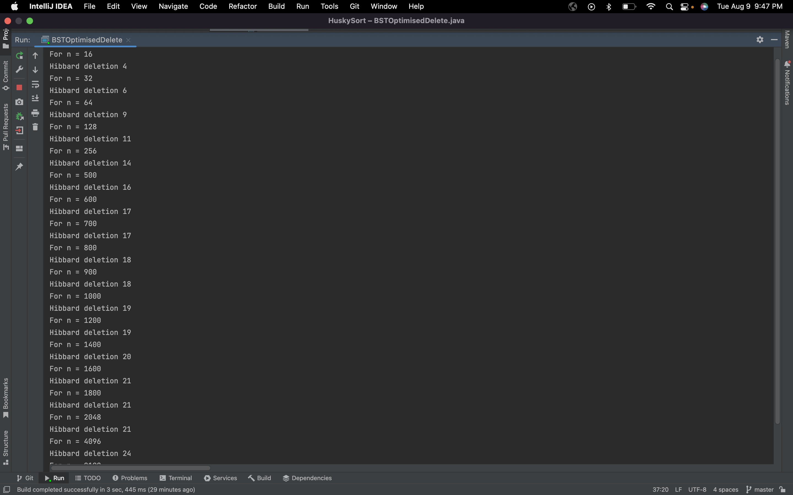

1. **Randomly choose which direction to look for the node to be deleted**

|  |  |  |
| --- | --- | --- |
| n | random deletion avg height | hibbard deletion avg height |
| 16 | 5 | 4 |
| 32 | 7 | 6 |
| 64 | 9 | 9 |
| 128 | 12 | 11 |
| 256 | 15 | 14 |
| 500 | 18 | 16 |
| 600 | 18 | 17 |
| 700 | 19 | 17 |
| 800 | 19 | 18 |
| 900 | 20 | 18 |
| 1000 | 20 | 19 |
| 1200 | 21 | 19 |
| 1400 | 22 | 20 |
| 1600 | 22 | 21 |
| 1800 | 23 | 21 |
| 2048 | 23 | 21 |
| 4096 | 26 | 24 |

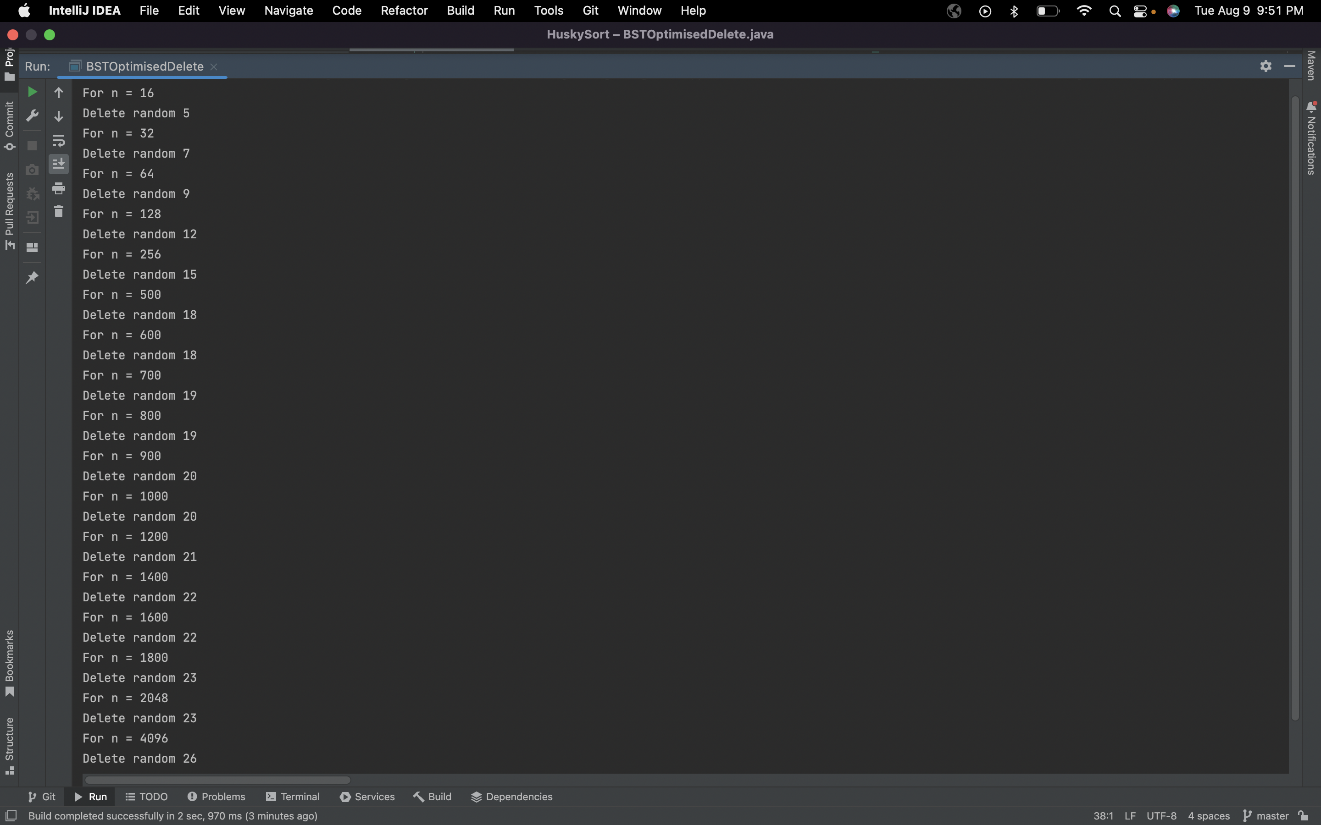

1. **choose the direction according to the size of candidate nodes**

|  |  |  |
| --- | --- | --- |
| n | deletion by size avg height | hibbard deletion avg height |
| 16 | 5 | 4 |
| 32 | 7 | 6 |
| 64 | 10 | 9 |
| 128 | 12 | 11 |
| 256 | 15 | 14 |
| 500 | 18 | 16 |
| 600 | 19 | 17 |
| 700 | 19 | 17 |
| 800 | 20 | 18 |
| 900 | 20 | 18 |
| 1000 | 21 | 19 |
| 1200 | 22 | 19 |
| 1400 | 22 | 20 |
| 1600 | 23 | 21 |
| 1800 | 23 | 21 |
| 2048 | 24 | 21 |
| 4096 | 26 | 24 |

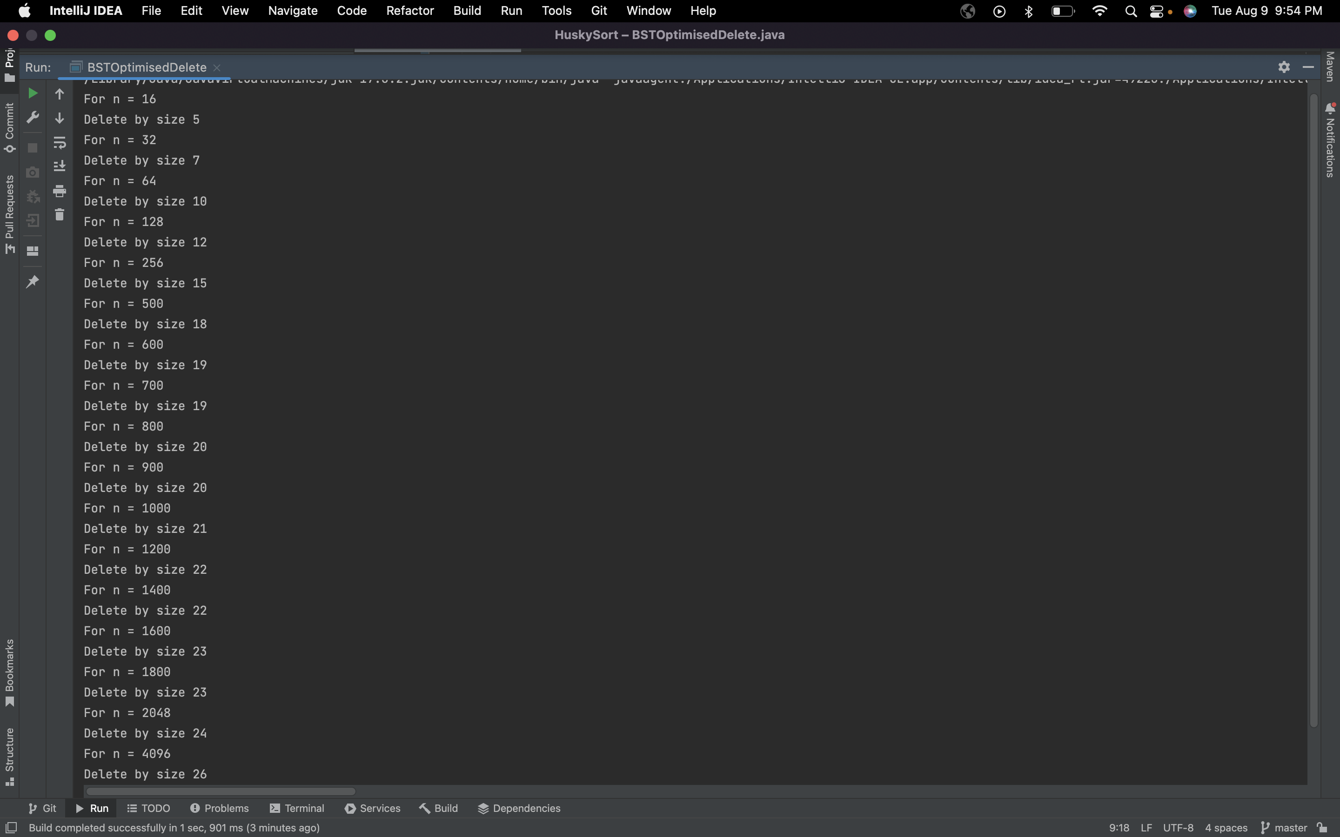

### Unit Tests

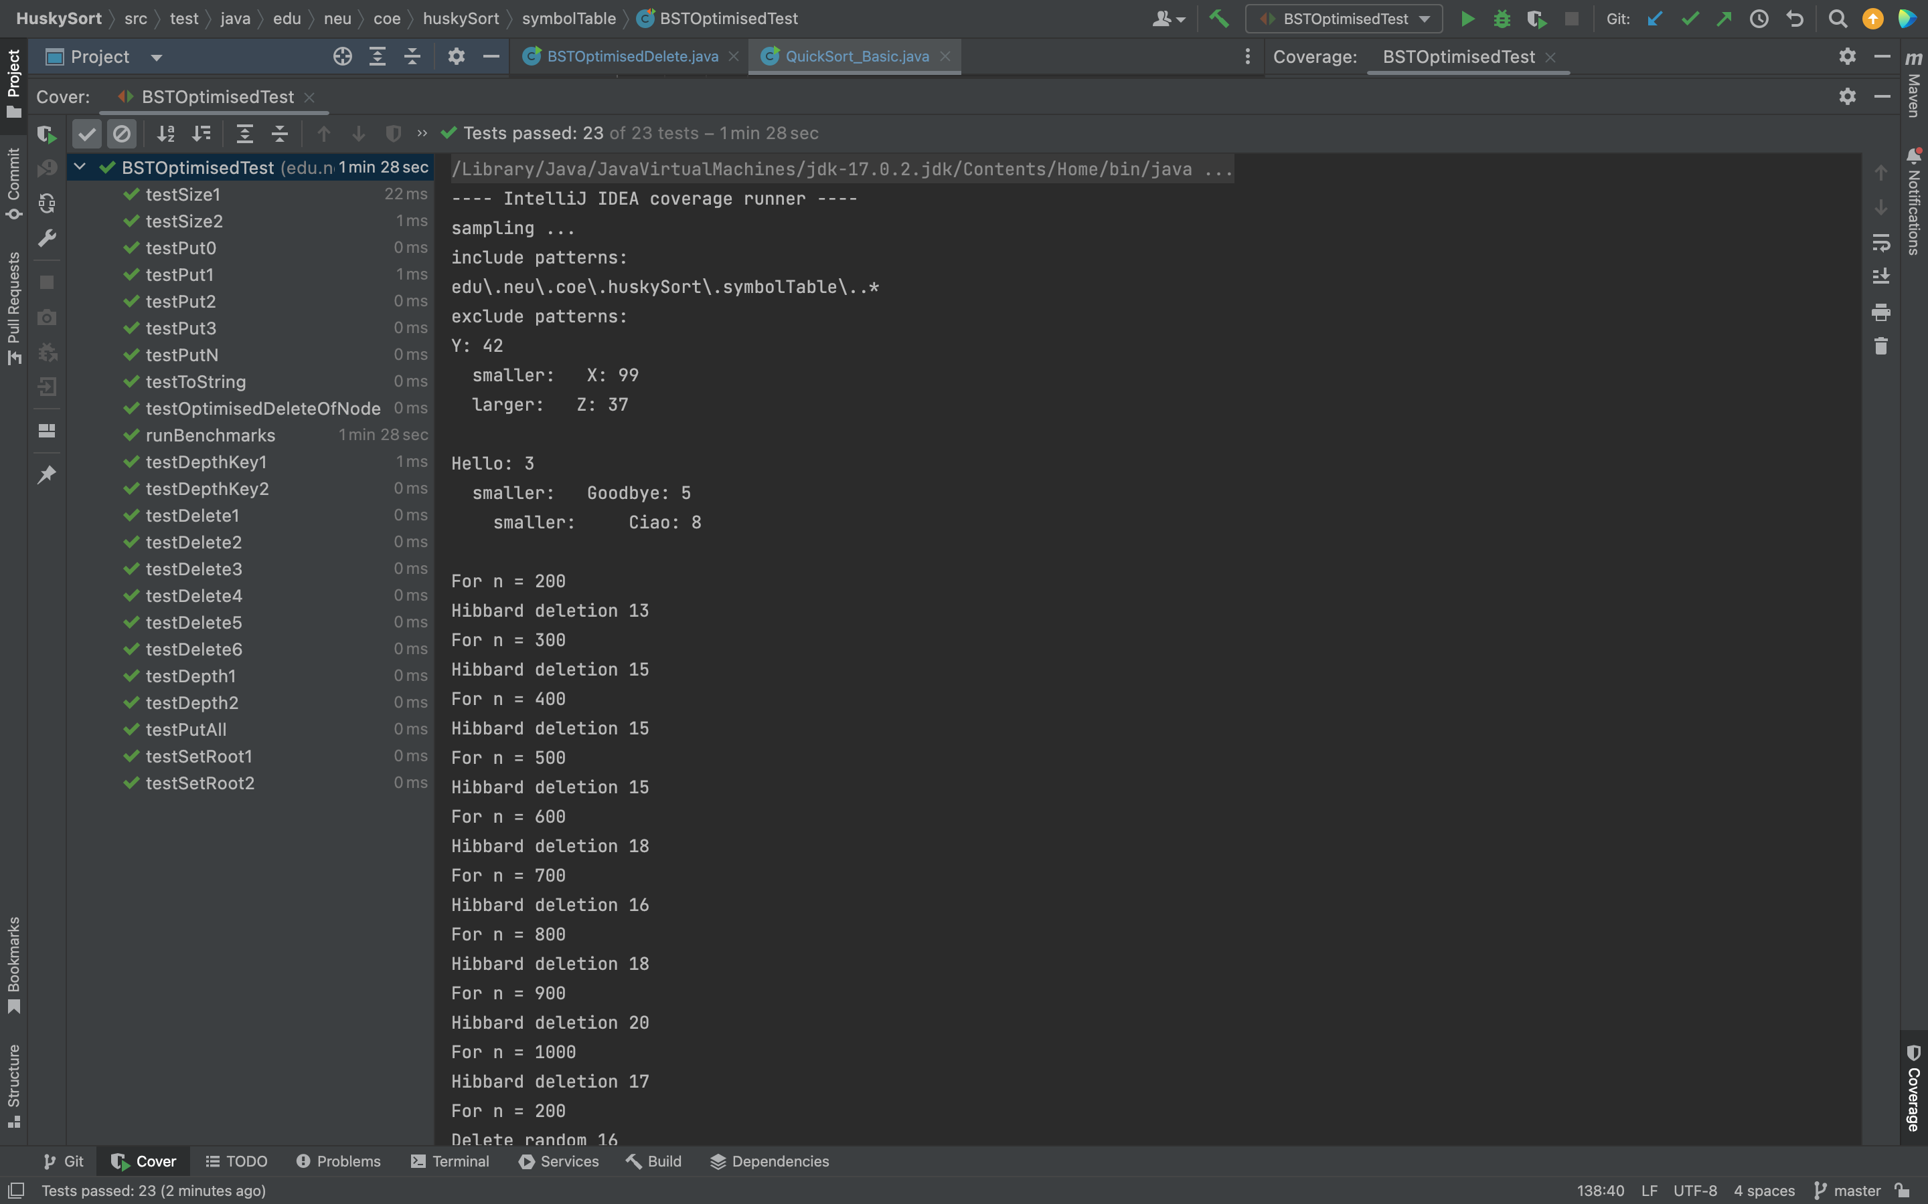

### Code Coverage

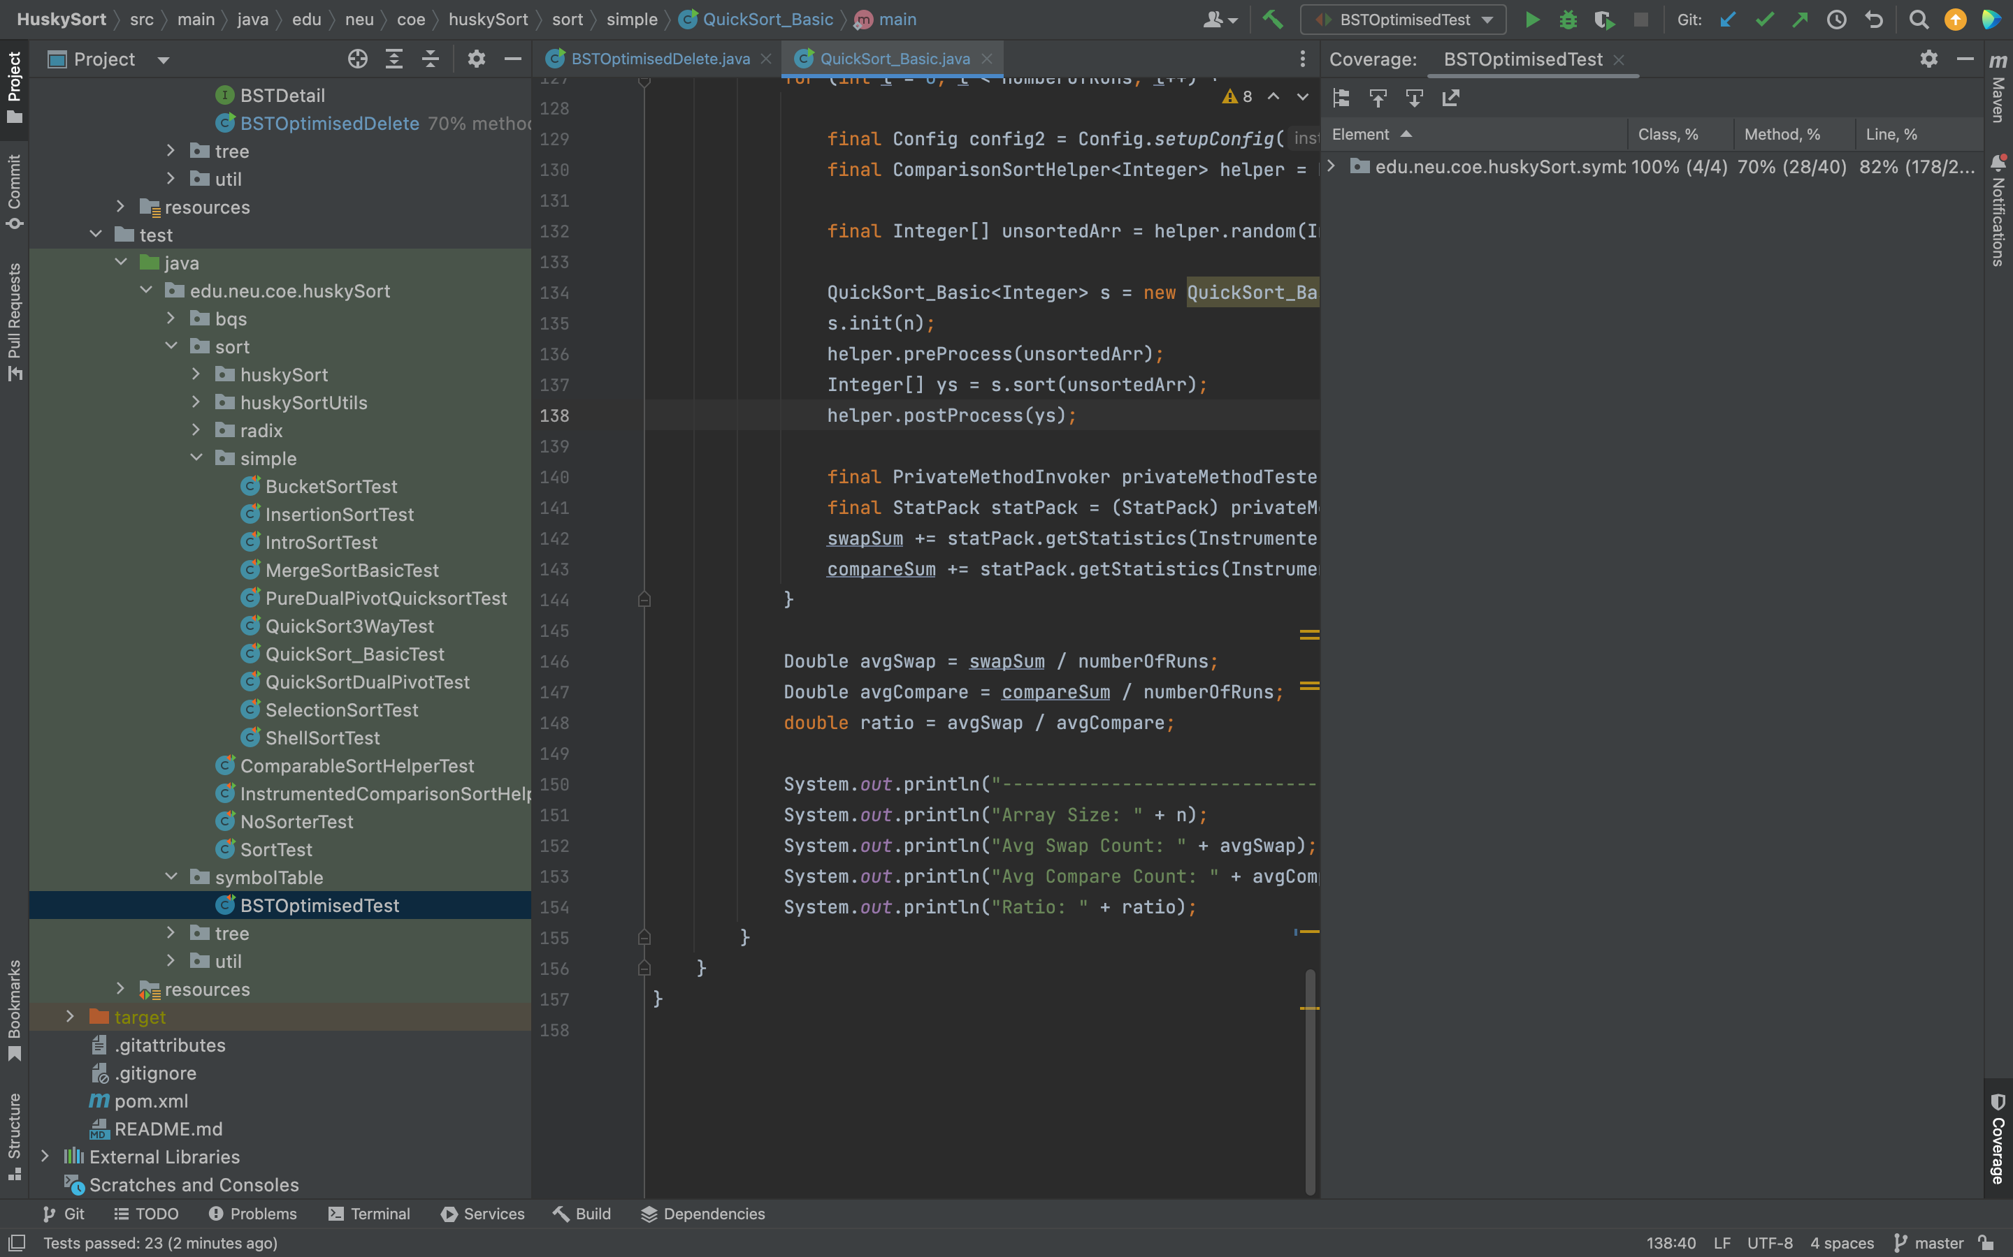

### Conclusion

1. The average height of BST after several (almost half of array size) Hibbard deletion is near to √𝑛 when the value of the array size is less than 256. As the value get larger the average tends to get closer to 2log(n). We conclude the cutoff for the relation to be 256.
2. When compared to selecting a node to be eliminated at random and Hibbard deletion, Hibbard deletion performs marginally better.
3. Similarly, Hibbard deletion performs better than choosing the node to be deleted based on the size.
4. It can be concluded that the Hibbard deletion is the most efficient deletion method for BST from the benchmarks above.

## QUICKSORT

### Code Links

[QuickSort_Basic.java](https://github.com/prasaddpathak/HuskySort/blob/master/src/main/java/edu/neu/coe/huskySort/sort/simple/QuickSort_Basic.java)

[QuickSort_BasicTest.java](https://github.com/prasaddpathak/HuskySort/blob/master/src/test/java/edu/neu/coe/huskySort/sort/simple/QuickSort_BasicTest.java)

### Analysis

*\* Note: Due to hardware limitations as the array size increases the avg runs need to be lower*

Swaps/Compare Ratio

|  |  |  |  |
| --- | --- | --- | --- |
| No of Runs | n | Benchmark Ratio | 1/6 Reference |
| 1000 | 16 | 0.36929108 | 0.166666667 |
| 1000 | 32 | 0.293010991 | 0.166666667 |
| 1000 | 64 | 0.266663868 | 0.166666667 |
| 1000 | 128 | 0.252224209 | 0.166666667 |
| 1000 | 256 | 0.235538471 | 0.166666667 |
| 1000 | 512 | 0.222596969 | 0.166666667 |
| 1000 | 1024 | 0.211444878 | 0.166666667 |
| 1000 | 2048 | 0.208324657 | 0.166666667 |
| 1000 | 4096 | 0.199367588 | 0.166666667 |
| 100 | 8192 | 0.198375098 | 0.166666667 |
| 100 | 16384 | 0.195519294 | 0.166666667 |
| 100 | 32768 | 0.193108923 | 0.166666667 |
| 3 | 65536 | 0.191516039 | 0.166666667 |
| 3 | 131072 | 0.187745357 | 0.166666667 |
| 3 | 262144 | 0.189798017 | 0.166666667 |
| 3 | 524288 | 0.187732235 | 0.166666667 |

Swaps and Compares

|  |  |  |  |
| --- | --- | --- | --- |
| No of Runs | n | Avg Swaps | Avg Compares |
| 1000 | 16 | 19.123 | 51.783 |
| 1000 | 32 | 42.893 | 146.387 |
| 1000 | 64 | 101.62 | 381.079 |
| 1000 | 128 | 226.232 | 896.948 |
| 1000 | 256 | 503.964 | 2139.625 |
| 1000 | 512 | 1125.288 | 5055.271 |
| 1000 | 1024 | 2482.72 | 11741.689 |
| 1000 | 2048 | 5441.679 | 26121.147 |
| 1000 | 4096 | 11792.67 | 59150.387 |
| 100 | 8192 | 25535.47 | 128005.7 |
| 100 | 16384 | 54774.04 | 280146.47 |
| 100 | 32768 | 117087.43 | 606328.43 |
| 3 | 65536 | 249276 | 1301593.333 |
| 3 | 131072 | 528731.667 | 2816217 |
| 3 | 262144 | 1119981.33 | 5900911.667 |
| 3 | 524288 | 2358405.67 | 12562603.67 |

### Output

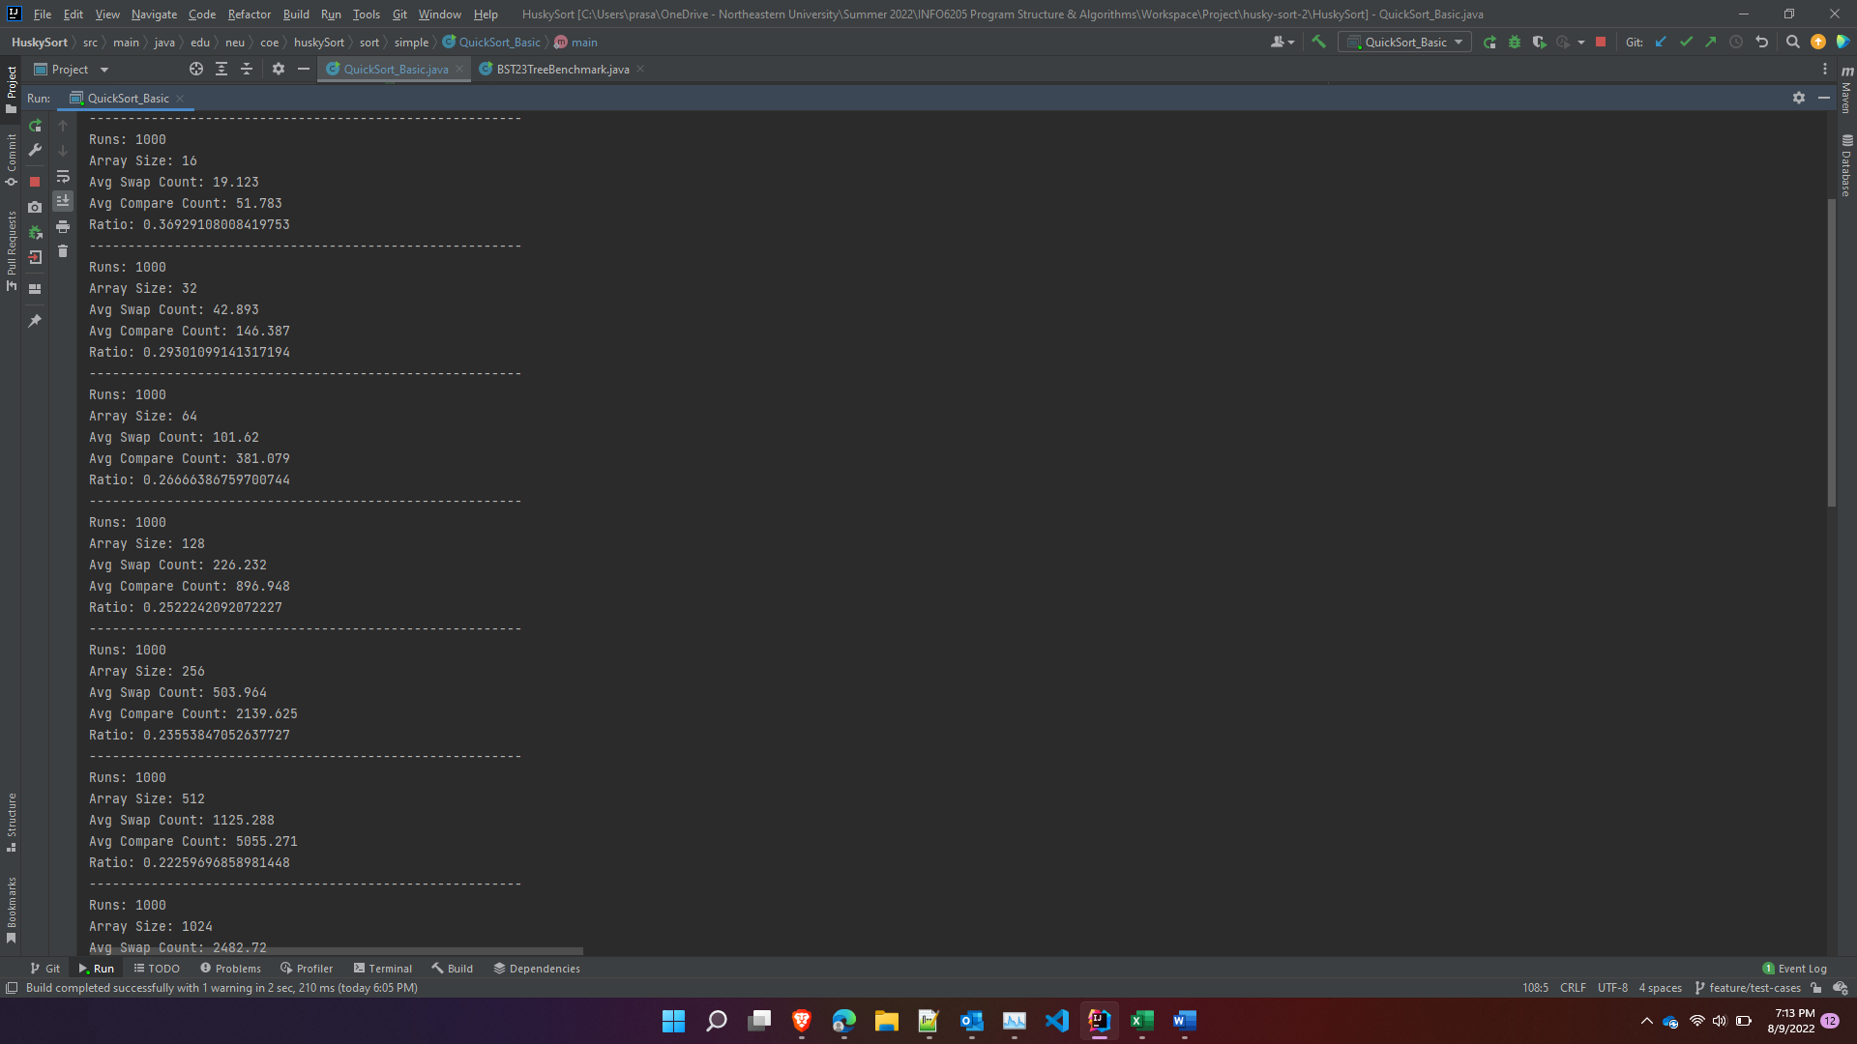

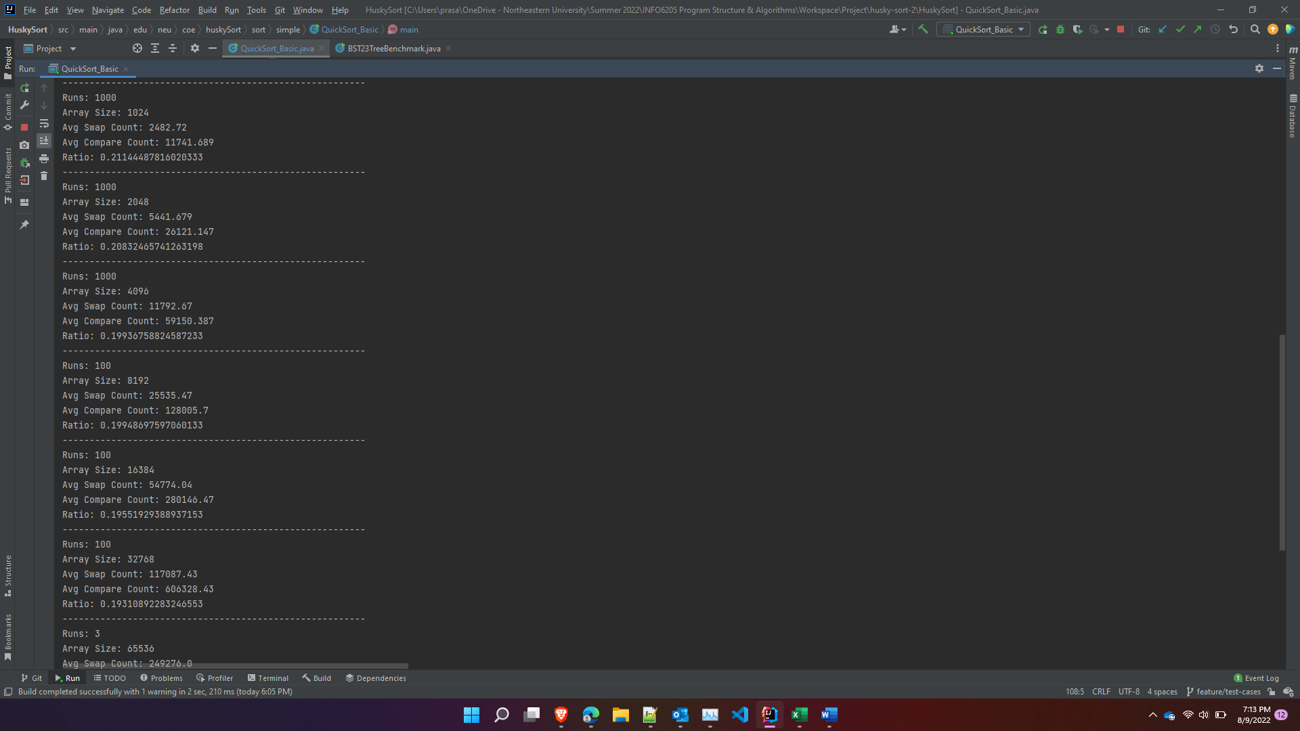

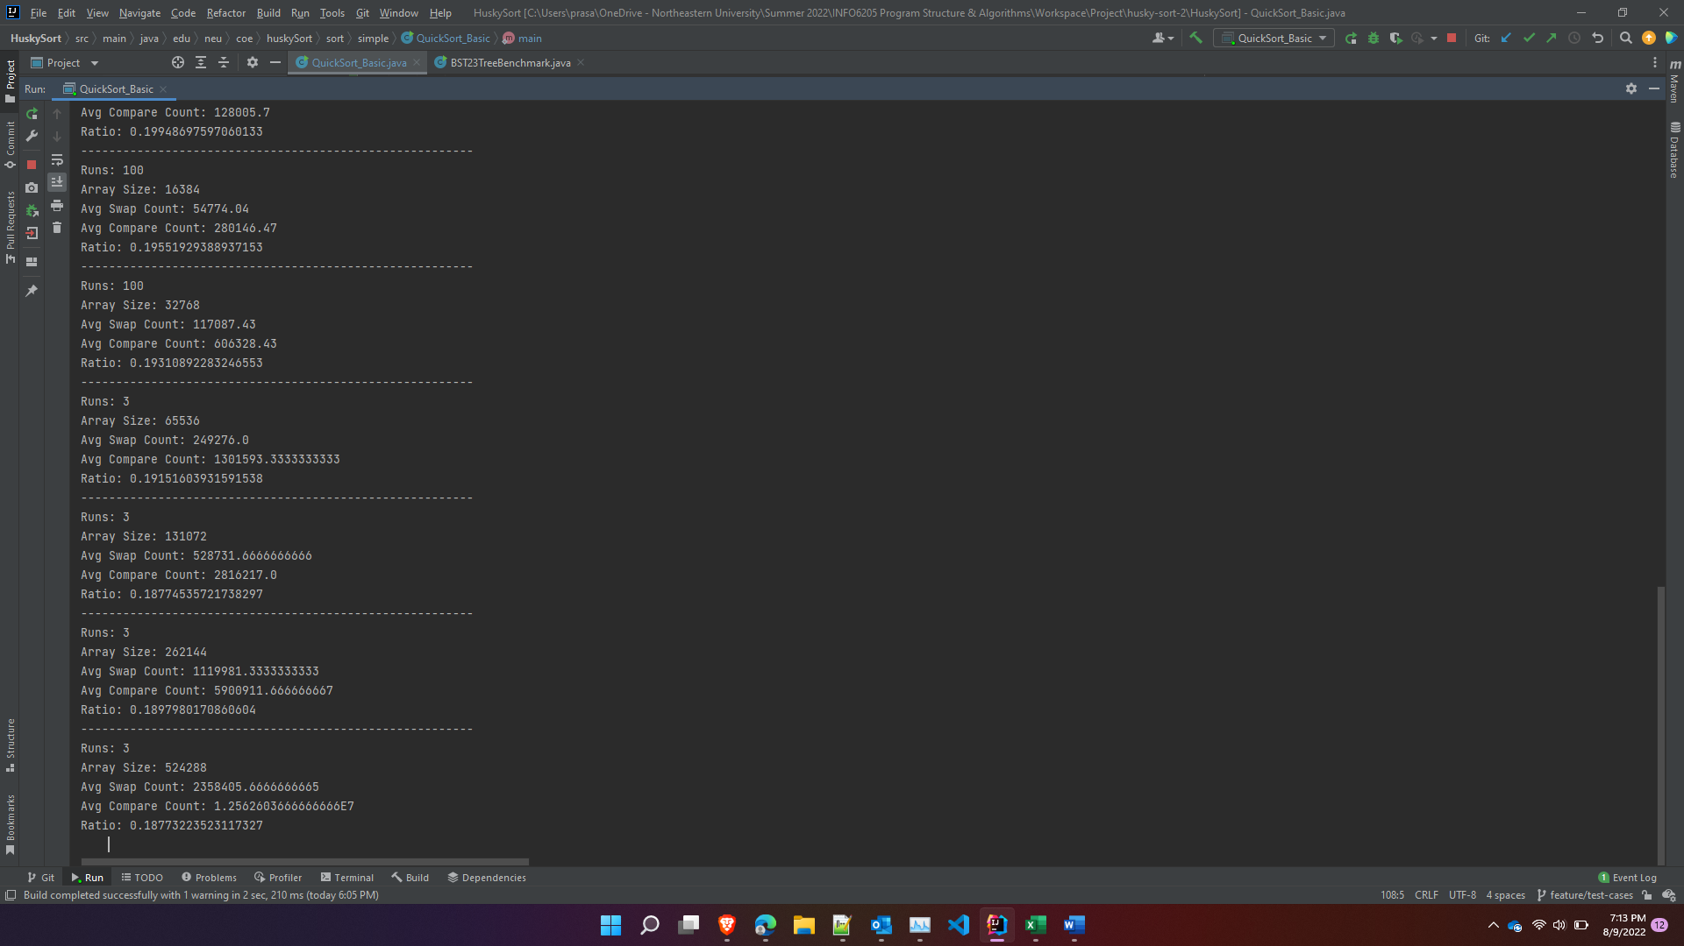

### Unit Test

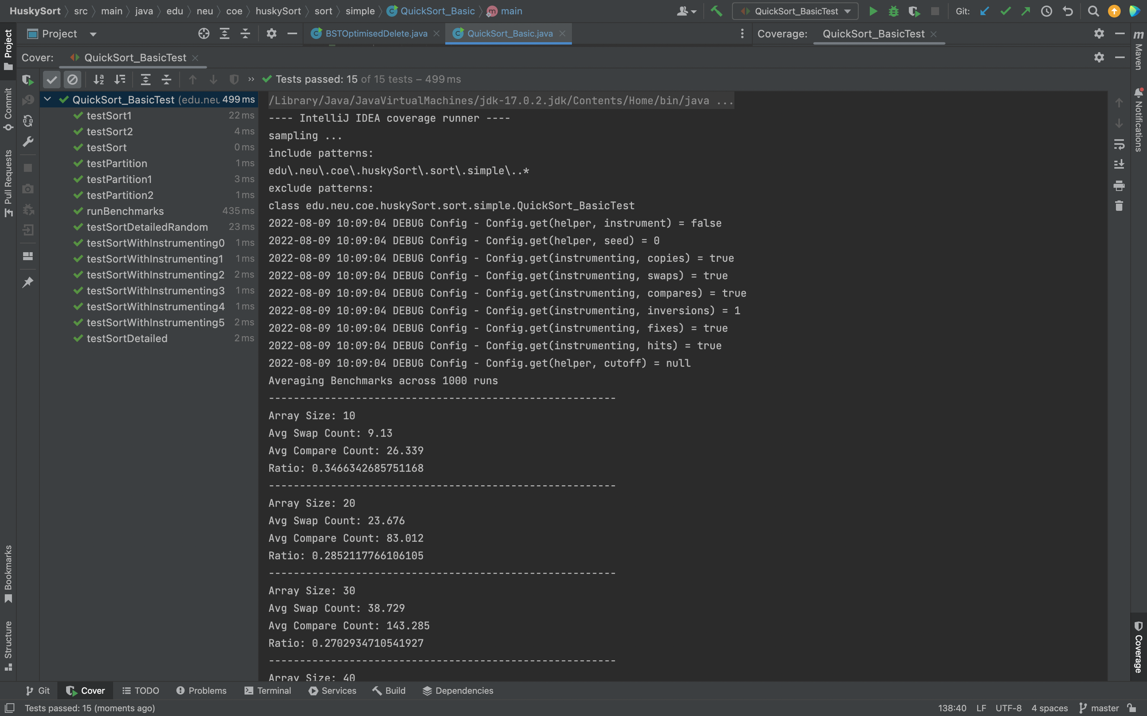

### Coverage

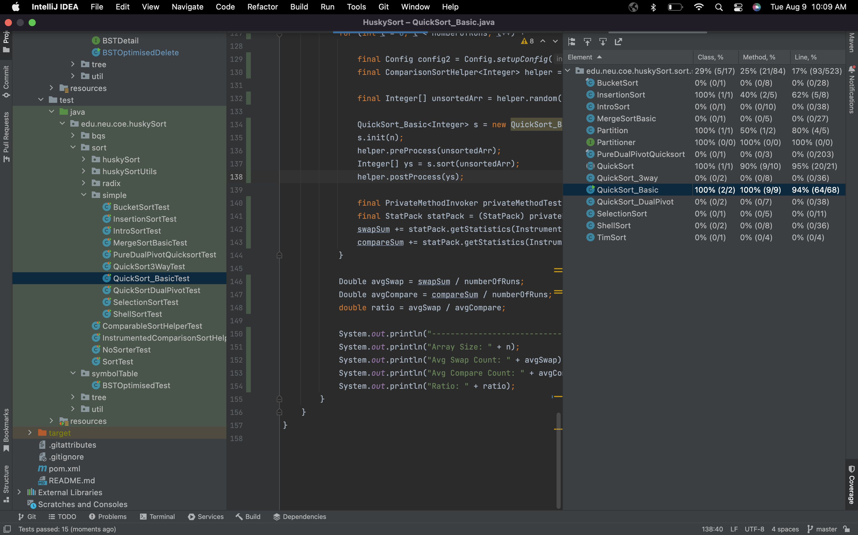

### Conclusion

1. The ratio of swaps to compare is near to 1/6 (0.1666) but not 1/6
2. As the size of the array increases the ratio tends towards 1/6
3. One reasonable explanation to this could be that as the size of array increases, there are more compares relative to swaps.

## 2-3 TREE

### Code Links

[TwoThreeTree.java](https://github.com/prasaddpathak/HuskySort/blob/master/src/main/java/edu/neu/coe/huskySort/tree/TwoThreeTree.java)

[BST23TreeBenchmark.java](https://github.com/prasaddpathak/HuskySort/blob/master/src/main/java/edu/neu/coe/huskySort/tree/BST23TreeBenchmark.java)

[TwoThreeTreeTest.java](https://github.com/prasaddpathak/HuskySort/blob/master/src/test/java/edu/neu/coe/huskySort/tree/TwoThreeTreeTest.java)

### Analysis

**Avg Time To Insert Per Key (Ns)**

|  |  |  |
| --- | --- | --- |
| n | BST | TTT |
| 1024 | 174 | 680 |
| 2048 | 146 | 522 |
| 4096 | 156 | 560 |
| 8192 | 184 | 658 |
| 16384 | 214 | 759 |
| 32768 | 248 | 873 |
| 65536 | 284 | 994 |
| 131072 | 332 | 1198 |
| 262144 | 405 | 1529 |

**Avg Depth of the Tree**

|  |  |  |
| --- | --- | --- |
| n | BST | TTT |
| 1024 | 21.75 | 8.01 |
| 2048 | 24.55 | 9 |
| 4096 | 27.32 | 9.97 |
| 8192 | 30.13 | 10.81 |
| 16384 | 33.07 | 11.44 |
| 32768 | 35.86 | 12.09 |
| 65536 | 38.62 | 13 |
| 131072 | 41.41 | 14 |
| 262144 | 44.24 | 14.98 |

**Avg Time To Search Per Key (nS)**

|  |  |  |
| --- | --- | --- |
| n | BST | TTT |
| 1024 | 66 | 63 |
| 2048 | 80 | 74 |
| 4096 | 93 | 90 |
| 8192 | 104 | 106 |
| 16384 | 117 | 118 |
| 32768 | 135 | 139 |
| 65536 | 154 | 162 |
| 131072 | 190 | 204 |
| 262144 | 233 | 249 |

### Output

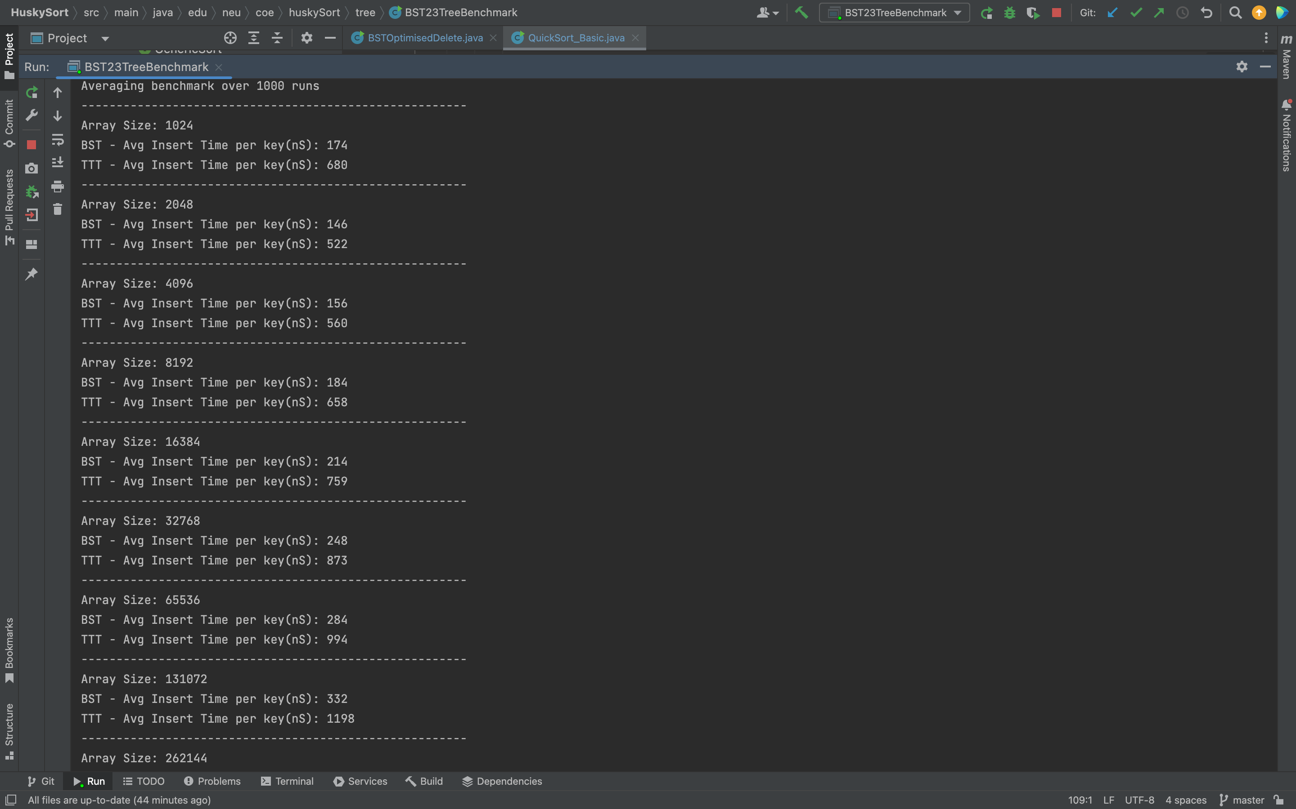

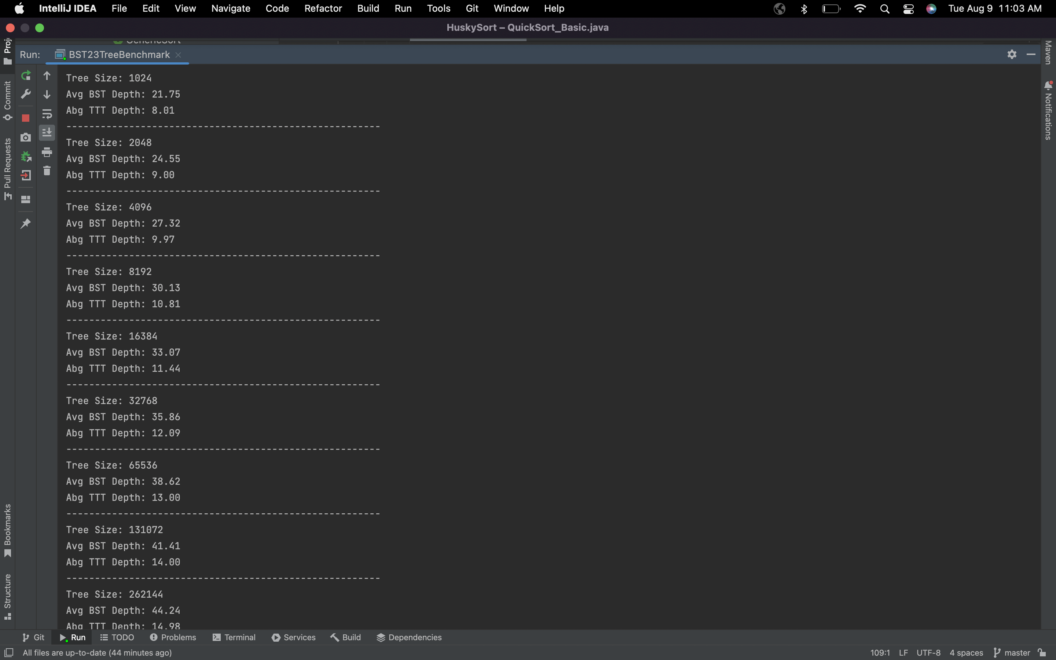

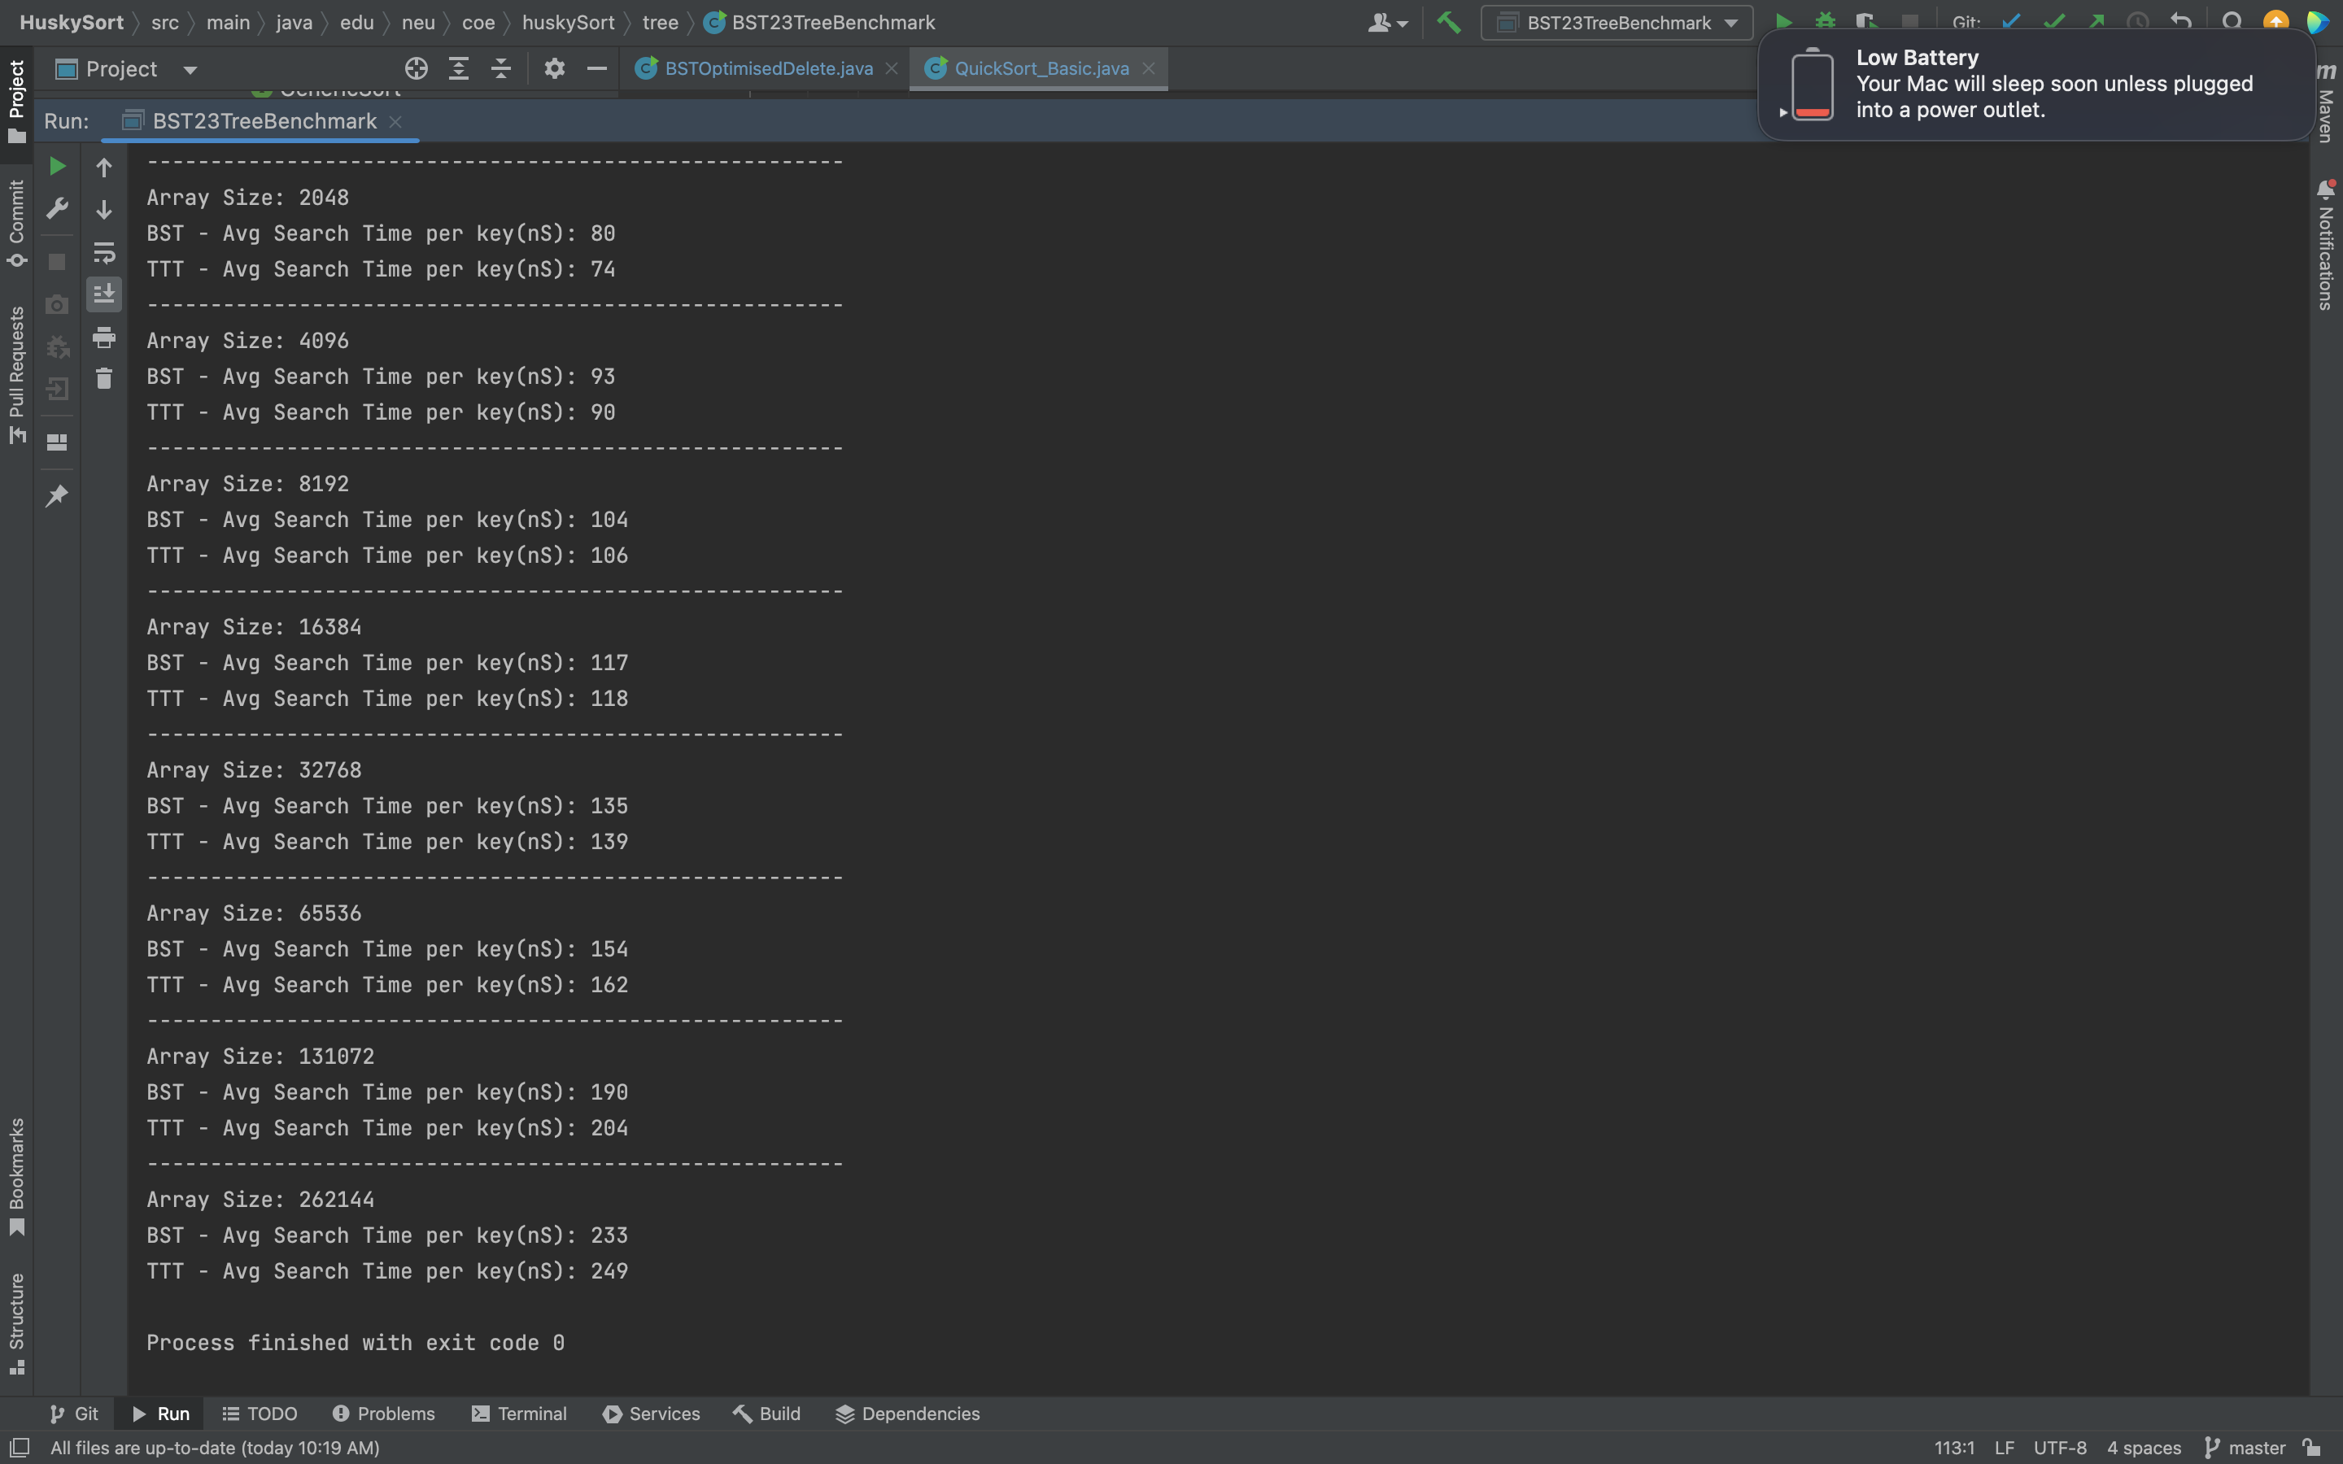

### Unit Test

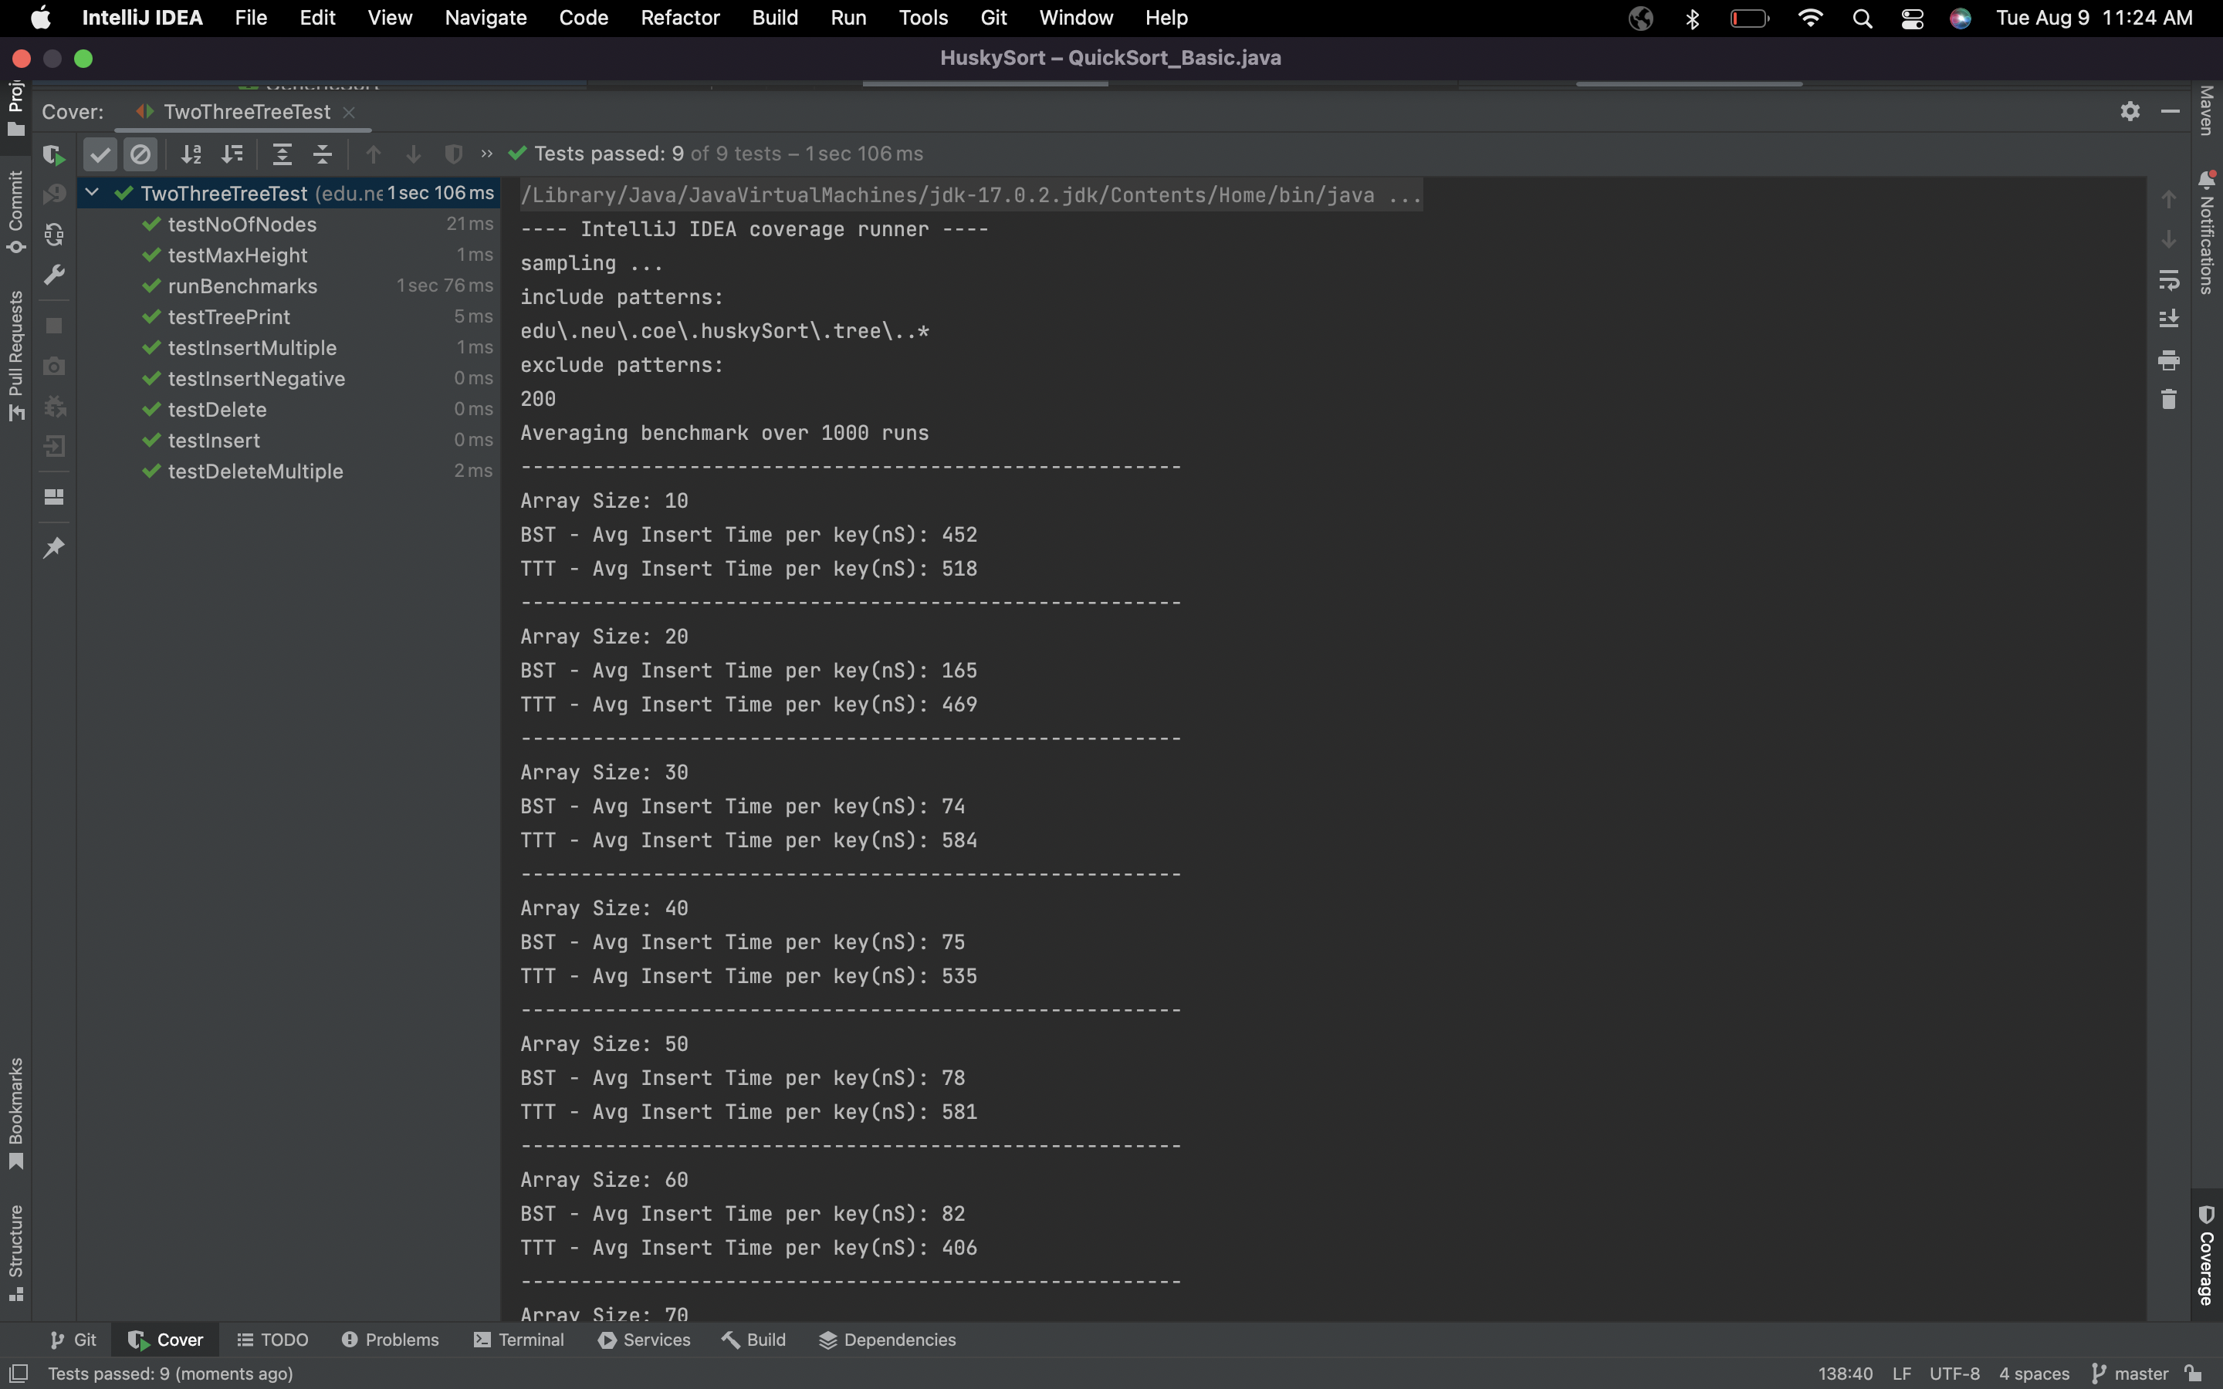

### Coverage

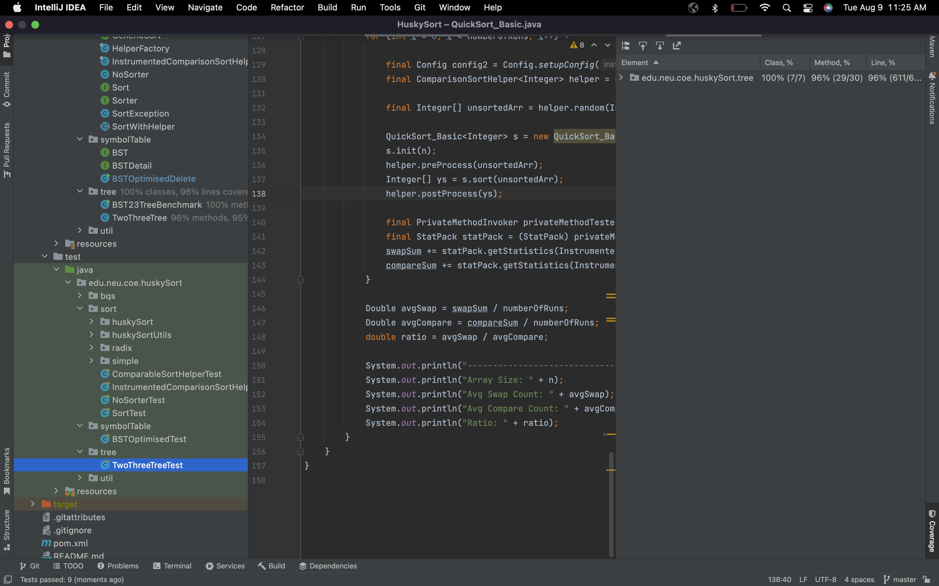

### Conclusion

1. The insert operation for 23Tree takes longer due to additional merge operations
2. The 23Tree is much shorter when compared to BST
3. Even though the tree is shorter, 23Tree and BST have similar metrics for search. This could be due to additional compares required in the 23Tree